I went into this project with the goal of identifying characteristics of individuals with serious mental health or drug abuse problems who don’t receive treatment for them. Of the 55,000 or so observations in the 2014 National Survey on Drug Use and Health, I decided to look at two major subsets of about 5,000 individuals each. The first group of interest is the subset of adults who experienced serious psychological distress in the past year (measured by the K6 mental health diagnostic questionnaire within the survey). The second group is the subset of adults who have been classified as dependent drug users or drug abusers. For each of the two subsets of adults, I fit a logistic regression model to predict whether or not someone with one of these conditions will receive treatment from a professional for their disorder or drug dependency.

My motivation for choosing to research mental health and drug abuse is to bring attention to the depths of these problems and their interconnectedness in the U.S. and to raise awareness for those who could benefit from getting treatment. There is more often than not a stigma associated with mental disorders in the United States, as most people have commonly held misconceptions that sufferers are dangerous, unpredictable, or somehow just “different”. People tend to hold these negative beliefs regardless of their age, exposure to mental health problems, or whether or not they know someone who is actually affected. Much of this stigma can be attributed to the low priority status of mental health within the healthcare industry and the depiction of persons with mental health disorders in the main stream media and entertainment industry. The social effects of this stigma serve to further reduce the quality of life of sufferers and hinder effective treatment and recovery from these disorders. Therefore if I can identify traits which raise a person’s likelihood of not seeking necessary treatment for mental disorders or drug abuse, we may be able to more easily identify people who need treatment and send them in the right direction.

The interconnectedness of mental health disorders and drug abuse can be attributed to the tendency of mental health patients to turn to self-medication to reduce the effects of their symptoms as well as the development of mental health problems as a result of compulsive drug use. According to the National Bureau of Economic Research, there is a definite connection between mental illness and the use of addictive substances, with mental health disorder patients responsible for the consumption of 38 percent of alcohol, 44 percent of cocaine, and 40 percent of cigarettes. Within my subset of adults experiencing serious psychological distress, I could look at the proportions of those who have ever used these drugs.

In my attempt to find variables which are predictive of someone experiencing serious psychological distress, I separated my subset into those who received treatment and those who did not. Using these two groups, I constructed histograms of my potential predictor variables and compared the distributions to each other and the total sample’s distribution. As I created these exploratory plots, I noticed some substantial differences in the distributions of key variables explained with accompanying visuals below:

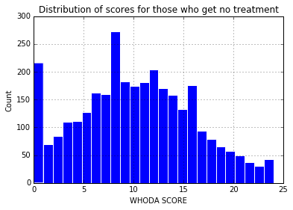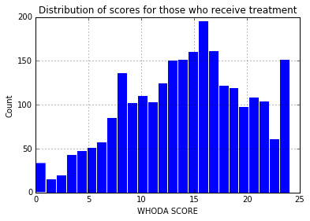

People who receive mental health treatment tend to score higher on the WHODAS, presumably because their emotions, nerves, or mental health tend to have a more severe effect on their daily lives.

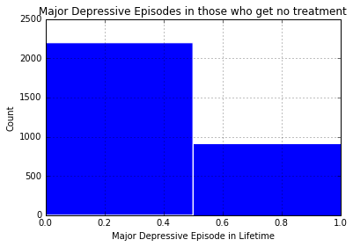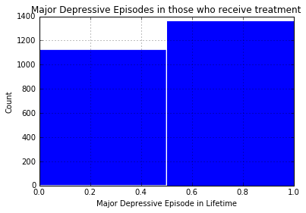

55% of people who receive mental health treatment have experienced a major depressive episode in the past year as opposed to only 29% of those who have not received treatment. \*need to fix x labels

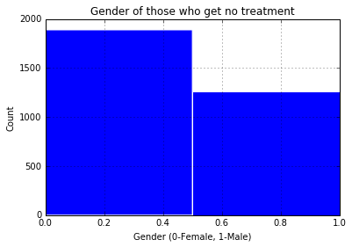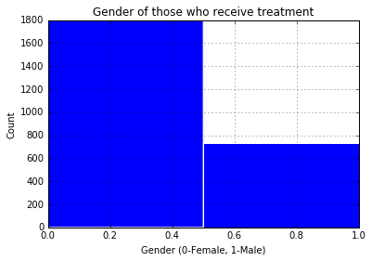

65% of those who experienced serious psychological distress in the past year are female.

Among these individuals, 71% of those who receive treatment for mental health in the past year are female and 60% of those who get no treatment for mental health are female. If this difference is significant, it would mean adult men who are experiencing serious psychological distress are less likely to seek out mental health treatment than their female counterparts.

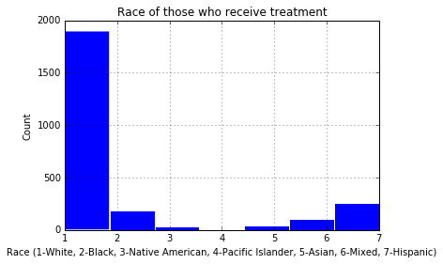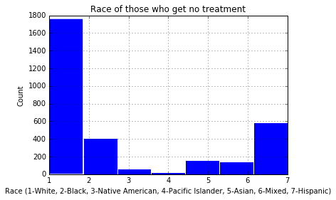

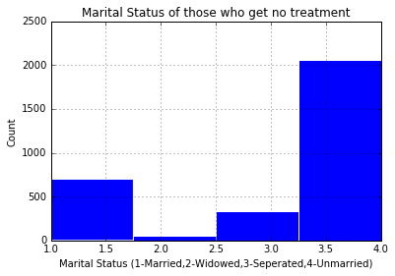It also seems to be the case that a much higher proportion of those who do not receive mental health treatment are not white. This seems to indicate that white adults experiencing severe psychological distress are more likely to receive the necessary treatment than non-whites.

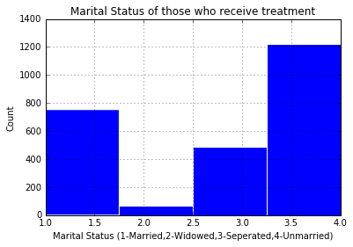

Adults who receive treatment for mental health are more likely to be widows, divorced, separated, or married. This means a large proportion of those who do not get treatment are unmarried. This led me to wonder whether or not age was responsible for this trend.

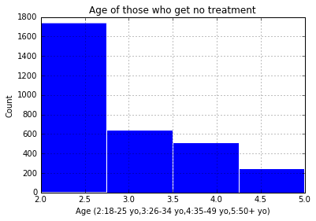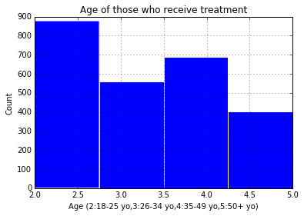

There seems to be a distinct difference between the distributions of age for those who receive treatment for mental health and those who don’t. Those who receive treatment have closer to a uniform distribution of ages, while those who don’t get treatment are mostly between the ages of 18 and 25. This could explain the distribution of marital status shown before and raises the question: Why are young people less likely to have their mental health problems addressed with treatment? It could have to do with the stigma associated with mental health, or perhaps a higher proportion of drug abuse manifesting as psychological distress, or simply just a lack of individual resources for affording treatment.

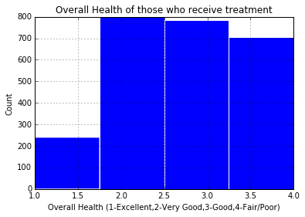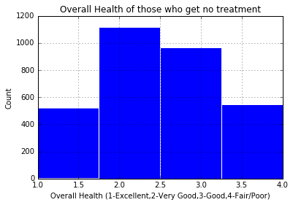

I also noticed that those who receive treatment had a higher proportion of adults with low overall health and a lower proportion of adults with excellent overall health. This could possibly mean that adults with excellent overall physical health are less likely to seek legitimate treatment for mental illness because they are otherwise in good health.